Traffic Simulating System
Use-Case Specification: View Statistic

Version <2.0>

Revision History
Date | Version | Description | Author
05/OCT/2008 | 1.0 | Draft | Xiangru Chen
04/JUN/2009 | 2.0 | Final Version | Xiangru Chen

Table of Contents
View Statistic 4
Brief Description 4
Flow of Events 4
Basic Flow 4
Alternative Flows 5
Special Requirements 5
Preconditions 5
Available Roads and Cars 5
Postconditions 5
Extension Points 5
Real-time Diagram 5

Use-Case Specification: View Statistic

View Statistic

Brief Description
This use case allows a City Planner to view the statistics from the simulating system.

The main actor of this use case is City Planner.

Flow of Events

Basic Flow
- The user moves the mouse on a road.
- The statistics information is retrieved from the Statistics System.
- The user interface draws the statistics information on the map, within a box near the mouse.
- When the user moves the mouse out of the road, the box contains statistics information is erased.
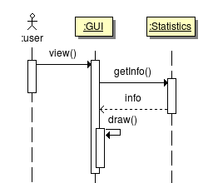

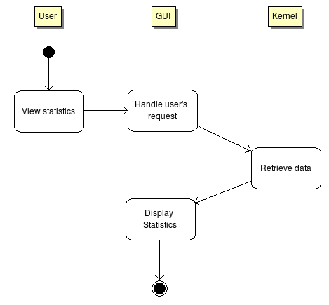
Alternative Flows
There are no alternative flows associated with this use case.

Special Requirements
There are no special requirements associated with this use case.

Preconditions

Available Roads and Cars
There must be some cars running on the roads before the statistic system can collect data and analyze.

Postconditions
There are no postconditions associated with this use case.

Extension Points

Real-time Diagram
Maybe we can draw real-time diagrams to show the statistics in future.

